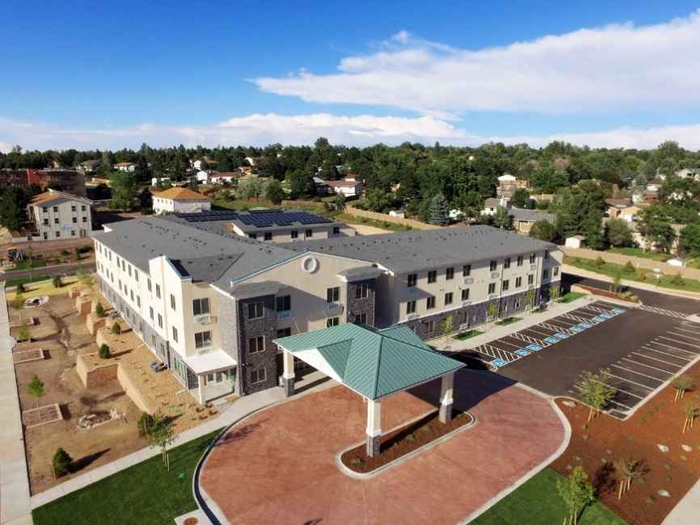

Hatler–May Village, located in Colorado Springs, CO, is a contemporary 77-unit affordable senior housing development serving low and very-low income households. The property was developed, and is managed, by Christian Church Homes (CCH) which has been, serving seniors in Springs since 2005. Hatler-May Village is designed to provide an attractive, durable, sustainable, and age accessible community which provides quality senior housing and relevant social services. The property consists of a 3-story wood-frame building with an elevator, ample community gathering spaces, landscaped courtyard with exercise stations, surface parking, views of Pike’s Peak, and a porte cochere entry. The project participates in the Enterprise Green Communities certification program, and features resource efficient building materials, water conservation measures, and modern green building techniques.



Hatler-May Village



# Property Basics

77 Apartment Homes

* + 59 one-bedrooms and 18 two-bedrooms
  + 12 fully accessible units; 100% adaptable units
  + Kitchen, bed, bath, living room, closets, EnergyStar appliances, and washer/dryer

Income Targeting to low and very-low income seniors

* + 40% - 60% AMI

# Financing Plan

City of Colorado Springs $500,000

State of Colorado $300,000

National Equity Fund/LIHTC $11,900,000

Solar Investment Tax Credit $29,000

Deferred Developer Fee $173,000

CFHA Mortgage $ 1,450,000

Total Development Costs: $14,352,000

# Special Features

* Onsite Property Management and Services Coordination
* Age Accessible Design
* Multipurpose Community Rooms
* Computer Center
* Outdoor Exercise Stations
* Rooftop Solar Panels