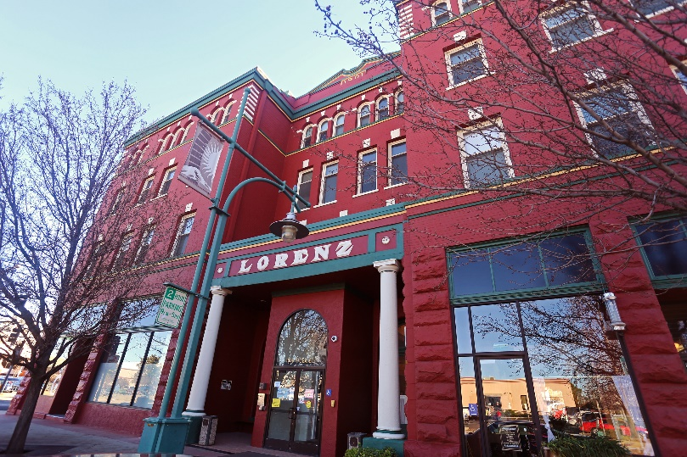
Property Basics
Originally built in 1901 by Susan Lorenz in the Beaux Arts/Renaissance Revival style, Lorenz Senior Apartments was converted into senior apartments in 1975 by a previous owner. CCH purchased the property from a HUD foreclosure in 1995, listed it on the National Register of Historic Places in 2010, and completed a major renovation in 2012 using Low-Income Housing Tax Credits paired with Federal Historic Tax Credits. The residents benefit from 100% Section 8 Project Based Rental Assistance. As part of the renovations, the property was converted from single room occupancy apartments without full bathrooms and kitchens to complete studio and one-bedroom apartments with fully accessible bathrooms and universal design kitchens. Significant seismic upgrades, 20% energy reduction through onsite generation, and other building systems enhancements were completed to ensure this property can sustainability serve seniors for many years into the future.
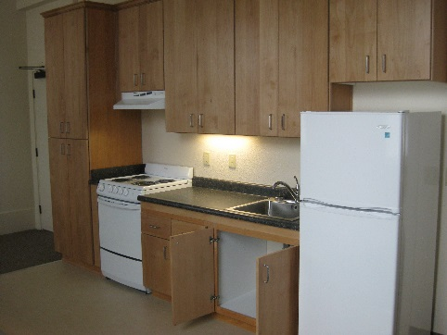
Lorenz Senior Apartments
60 Apartment Homes
- 24 Studios and 36 one-bedrooms
- 3 Fully Accessible and 100% Adaptable Design
8 Commercial Tenants
Income Targeting to extremely low and very low income seniors: 30% - 50% AMI

Financing Plan
Citibank Loan $1,600,000
City HOME Funds $620,000
Merritt CCC/LIHTC $ 7,680,000
Affordable Housing Program $590,000
GP Equity $450,000
Deferred Developer Fee $250,000
Property Donation Value $2,380,000
Total Development Costs: $13,570,000

Special Features
- National Register of Historic Places Listing
- Onsite Property Management and Service Coordination
- Mixed use, transit oriented property with major restaurant tenant
- Located in the heart of downtown Redding
- Onsite laundry and Computer Center
- Rooftop Solar Panels
- Resource efficient materials and interior finishes

