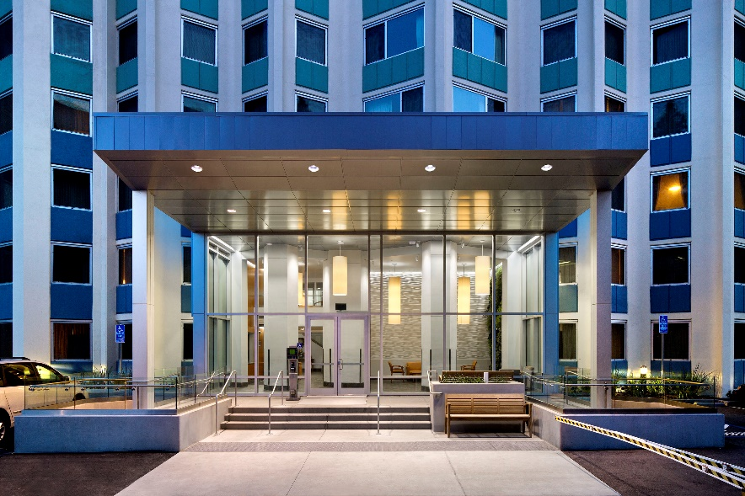
Property Basics
Built in 1968 with a HUD 202 Supportive Housing for the Elderly loan, Westlake Christian Terrace East was the second affordable senior property developed by Christian Church Homes. For almost five decades, it has been home to 200 of Oakland’s seniors. Leveraging HUD’s 202 Preservation Incentives with Low-Income Housing Tax Credits and tax-exempt bonds, Westlake East was the first property in the nation to prepay a HUD 202 loan, defer a HUD Flexible Subsidy loan, and secure Tenant Protection Vouchers for the preservation of this important property. The substantial renovation includes upgrades to all apartments, significant seismic strengthening, redesign and enlargement of the entrance lobby, creation of a new community lounge and computer center, accessibility improvements throughout the property, and energy efficiency upgrades that exceed Title 24 code.
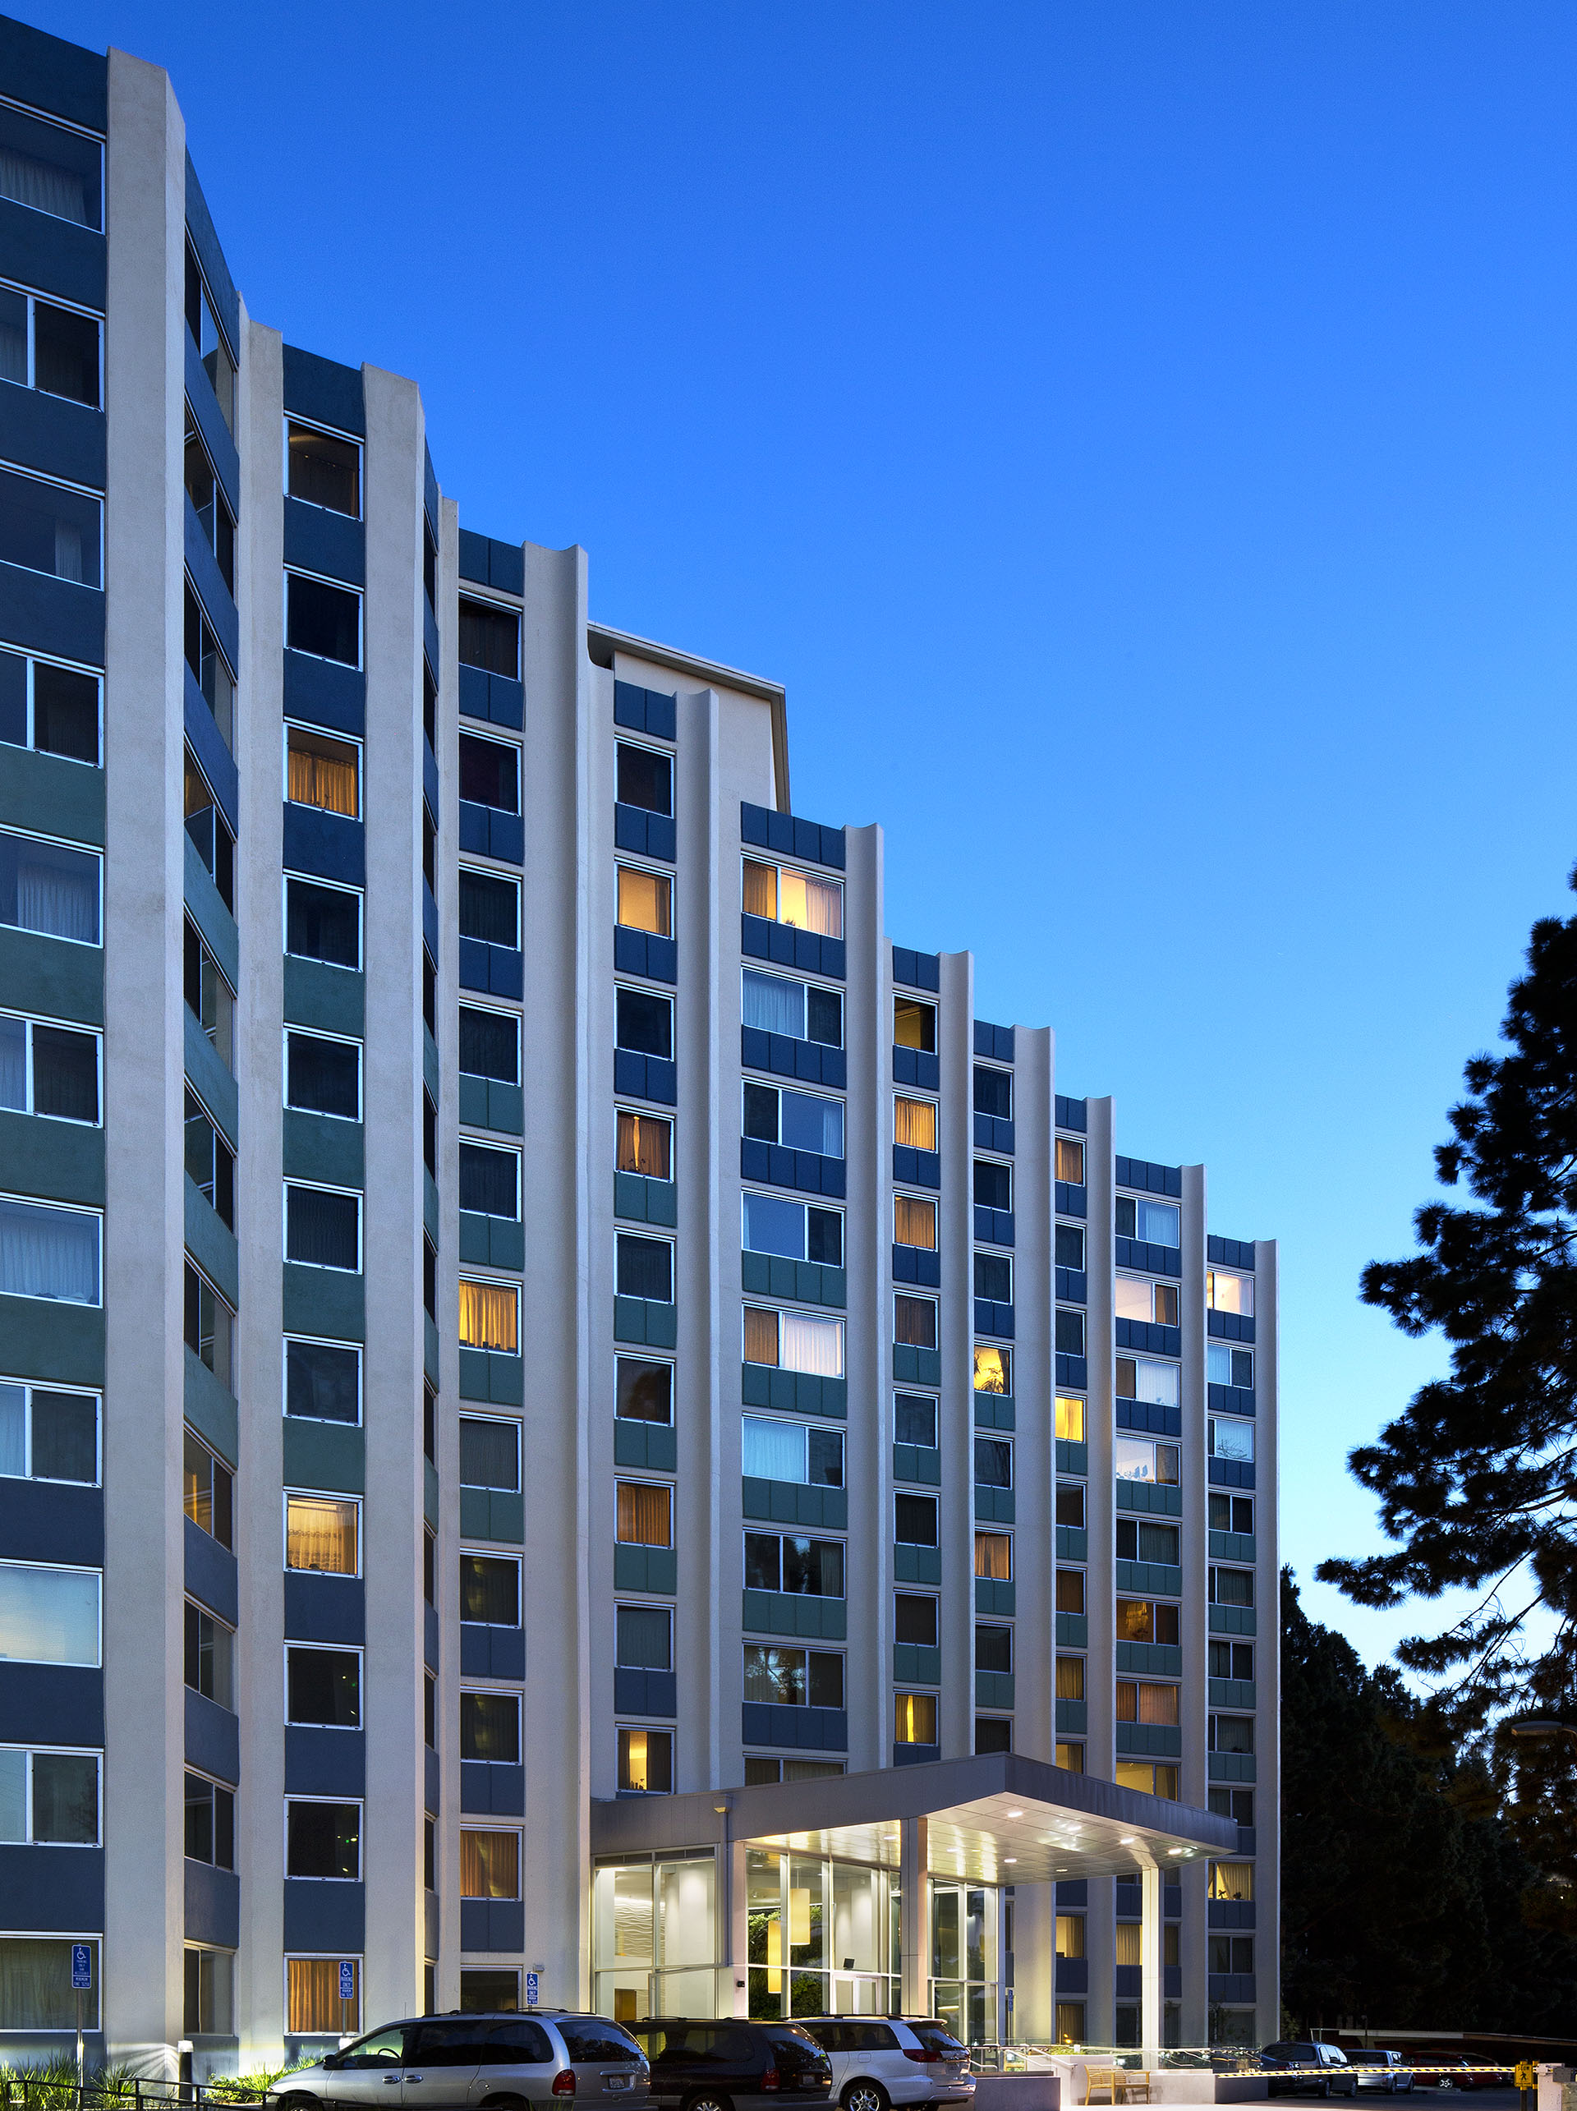
Westlake Christian Terrace East
200 Apartment Homes
  - 156 studios and 44 one-bedrooms
  - 16 fully accessible and HVI units
Income Targeting to low and very-low income seniors
  - 40% - 60% AMI

Financing Plan
Enterprise/LIHTC $16,400,000
Citi Bank Mortgage $12,900,000
HCD CHRP Loan $4,000,000
HUD Flex Subsidy Loan $3,000,000
Seller Loan $7,300,000
Affordable Housing Program $1,400,000
Total Development Costs: $ 45,000,000

Special Features
  - Onsite Property Management and Social Service Coordination
  - Computer Center
  - Laundry Room and Library
  - Multipurpose community room with kitchen, bbq and garden courtyard
  - Electronic key entry to building and apartments
  - Green wall in main lobby
  - Additional parking with secure access
  - GreenPoint Rated Score of 138

