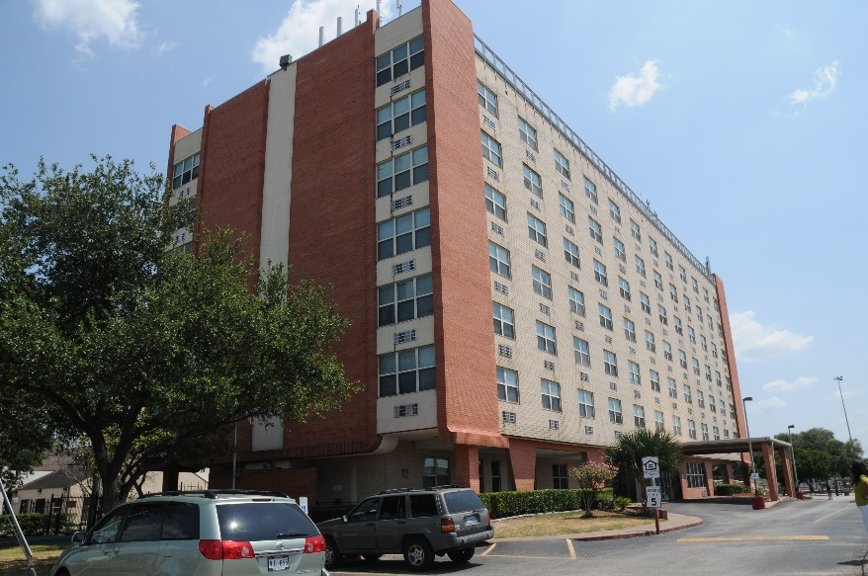
Woodland Christian Towers is a 127-unit apartment building located in the Northside neighborhood of Houston, Texas. Built in 1971 with a HUD 236 loan, this property has been serving very low and extremely low income senior and disabled persons for over 40 years. All residents benefit from Section 8 Project Based Rental Assistance. Once completed, the substantial renovation of Woodland Christian Towers will include a new Federally Qualified Health Clinic (FQHC). In addition to providing this underserved community with primary medical, dental, behavioral and mental health services, the FQHC will also provide case management and housing stabilization services to formerly homeless households living at Woodland. The project is part of the City of Houston’s Initiative to End Homelessness which has made remarkable progress in reducing the City’s homeless population. CCH is excited to partner with HUD, the local jurisdictions, and the health care community on an emerging model to blend federal housing and healthcare dollars and raise the bar in effective housing and services for our vulnerable community members.
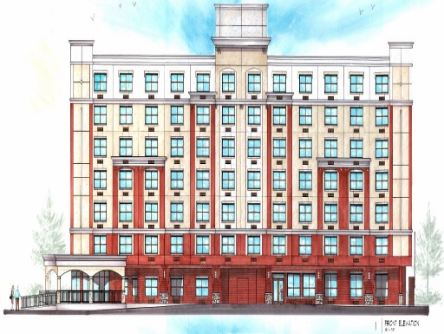
Woodland Christian Towers

Property Basics
127 Apartment Homes
- 84 Studios, 42 one-bedrooms, 1 two bedroom
- 8 Fully Accessible Units
Income Targeting to extremely low and very low income seniors and persons with disabilities
Occupancy preference for Formerly Homeless Persons
- 72 Permanent Supportive Housing Units

Financing Plan
Houston HOME Funds $3,450,000
County HOME Funds $1,940,000
National Equity Fund/LIHTC $6,300,000
Freddie Mac Loan $3,200,000
HUD Flexible Subsidy Loan $670,000
Corporation for Supportive Housing Grant $1,300,000
Enterprise Capacity Grant $77,000
Property Reserves $170,000
CCH Deferred Developer Fee $1,200,000
Total Development Costs: $18,307,000

Special Features
- Federally Qualified Health Clinic onsite
- Resource efficient materials and interior finishes
- Onsite Property Management and Service Coordination
- Computer Center
- Multipurpose Community Room

