# S:\housing development\02_Current\Garfield\Marketing & Photos\Grand Re-Opening\Site Photos 032216\IMG_3457.JPGProperty Basics

Garfield Park Village was the first senior housing community constructed by Christian Church Homes in 1964. It is named after President Garfield, and is located in the Circles Neighborhood, a former Disciples of Christ (Christian Church) revival camp. It was one of the first affordable senior housing projects funded by HUD under the Section 202 Supportive Housing for the Elderly Program. As a preservation project, and in partnership with HUD, Garfield Park Village was the first Senior Project Rental Assistance Contract (SPRAC) program award recipient to close construction financing and complete a major renovation with mixed financing. Improvement highlights include reducing total energy consumption by 15%, replacing interior finishes with resource efficient materials, enhancing landscaping at the 5 acre campus to drought tolerate and edible varieties, and protecting existing residents through new project based subsidy.



Garfield Park Village

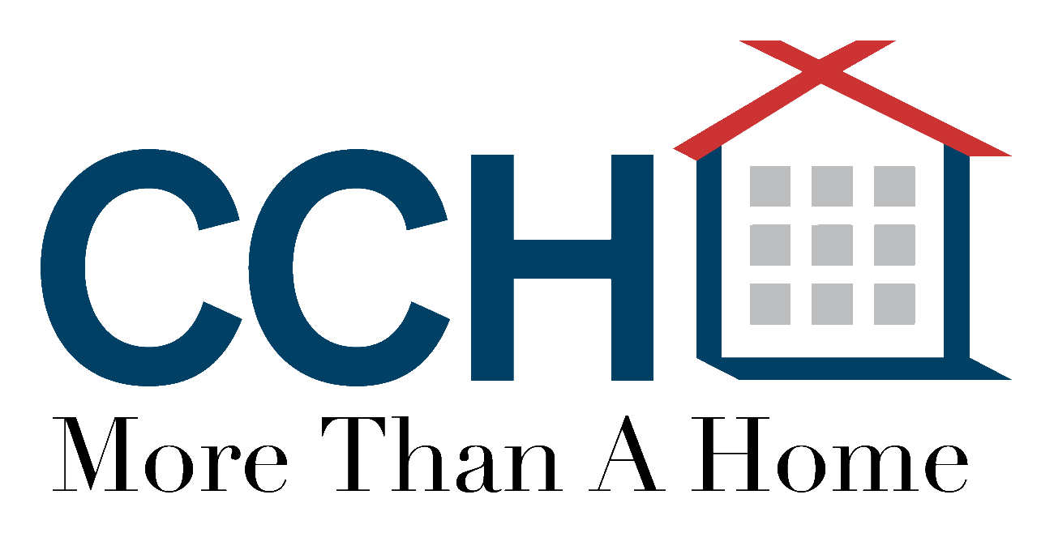

95 Apartment Homes

* 38 Studios, 48 one-bedrooms, 9 two-bedrooms
* 7 fully accessible units
* Kitchen, bed, bath, living rooms, closets, Energy Star appliances and fixtures

Income Targeting to low and very-low income seniors

* 50% - 60% AMI
* Section 8 and SPRAC Rental Subsidy

Financing Plan  
Union Bank Loan $8,600,000

City HOME Loan $755,000

Seller Carryback Loan $12,000,000

HUD Flex Subsidy $1,030,000

National Equity Fund/LIHTC $10,350,000

Sponsor Loan $400,000

Total Development Costs: $33,135,000

# Special Features

* Age Accessible and Green Building design techniques
* Enhanced landscaping with edible plants, walking paths, gardening boxes, and recreational amenities
* Onsite Property Management & Services Coordination
* Computer center and large community hall
* Colorful building palette for enhanced wayfinding