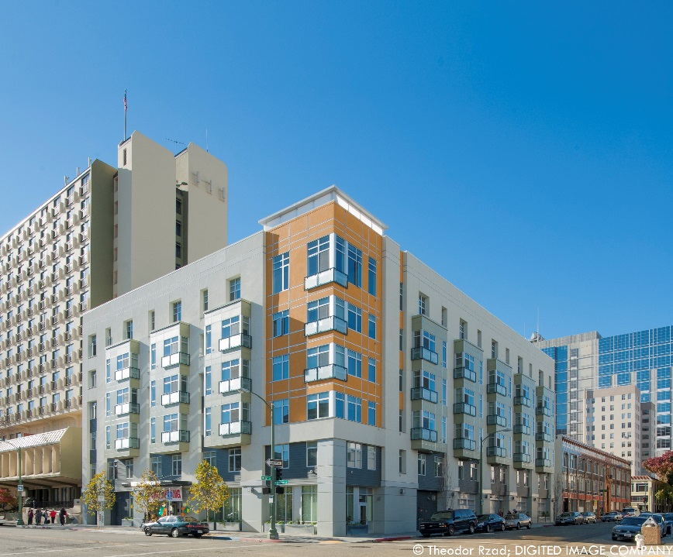
Property
Harrison Street Senior Housing a mixed finance, sustainable, and transit-oriented senior community. The project is a collaborative effort of Oakland Housing Authority’s nonprofit affiliate, Oakland Housing Initiatives, and CCH. Designed as a landmark building at the corner of Harrison and 17th Streets in downtown Oakland, this property is a major milestone for CCH’s smart growth efforts. Built on a former Chevron service station site purchased by the Housing Authority in 1993, the site was remediated by the former owner prior to construction. The L-shaped building has a vehicular entrance on 17th and pedestrian entrance on Harrison. With close proximity to public transportation and downtown Oakland amenities,, this deeply affordable senior community boasts a myriad of sustainable features, from environmentally preferable materials and water conservation fixtures, to advanced mechanical ventilation and a community garden.
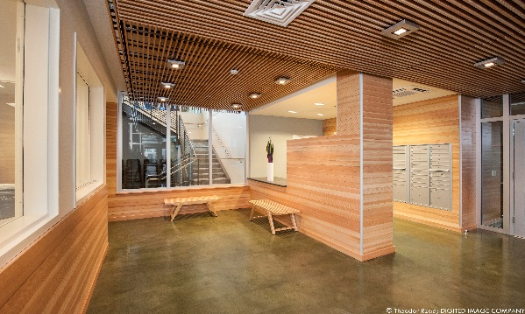
Harrison Street Senior Housing
73 Affordable Homes
- 72 one-bedrooms and 1 two-bedroom
- 5 fully accessible units, 100% adaptable
Income targeting to extremely low and very low-income seniors: 35% - 50% AMI
100% Project based rental assistance

Financing Plan
HUD 202 Capital Advance $8,600,000
Merritt CCC/LIHTC $6,600,000
Oakland Redevelopment Loan $5,100,000
Affordable Housing Program $720,000
HCD Infill Infrastructure Grant $500,000
Total Development Cost $21,520,000

Special Features
- Onsite Property Management and Service Coordination
- Green Point Rated Score 134
- Community Garden and Interior Courtyard
- 6th Floor Sky Lounge overlooking Lake Merritt
- Secure parking garage
- Computer Center and Community Room

